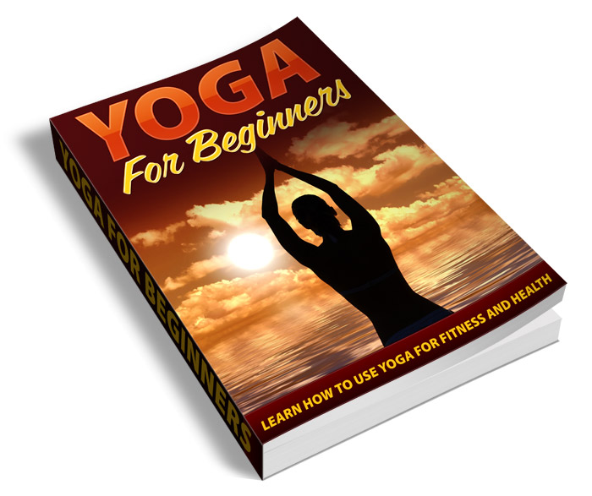
Yoga For Beginners

Table of Contents

Hatha Yoga 11
Raja Yoga 12
Karma Yoga 14
Bhakti Yoga 14
Jnana Yoga 15
Tantra Yoga 15
Bikram Yoga 15
Tips for Yoga Beginners 16
Yoga Equipment 19
Yoga Mats 20
Yoga Towel 21
Yoga Bags 21
Yoga Straps 21
Yoga Sandbags and Bolsters 22
Yoga Meditation Seating 22
Yoga Balls 22
Yoga Blocks 23
Yoga Videos 23
Yoga Music 23
Yoga Clothing 24
Types of Meditation 31
Concentrative Meditation 32
Mindfulness Meditation 33
What Happens When You Meditate? 35

Introduction

Yoga is an important part of many lives today. Although it is considered a type of exercise, it has the potential to affect the emotional and psychological health of the individual, not just the physical state.

Some people resist trying yoga. This may be because they believe it’s some kind of weird religious thing or that they must change their lifestyle completely.

While yoga was indeed used in years past mostly by hippies, the practice has evolved into a more mainstream system. All types of people use yoga for its ability to help the physical and mental states.

Meditation is also looked at in a similar way. There are many types of meditation. Not all meditation is about reaching “spiritual enlightenment” or using drugs and chanting.

Meditation can also be an extremely useful tool in controlling many physical and mental ailments. It can reduce stress and anxiety, help control panic attacks, ease depression, and much more. Its effects on the mental state can be remarkable, and it is recommended by many doctors as a great way to avoid taking medications.

We hope to enlighten you through this book so that you may learn how to practice yoga and meditation on your own. The physical and mental benefits you’ll receive will probably be shocking to you!

One thing you should realize is that while this book will be talking about the religious practices and history of yoga and meditation, you do NOT have to change your religion or subscribe to any of the religious notions of either method!

The information contained about the spiritual side is purely for informational purposes only. Yoga isn’t a religion, but it can have spiritual effects for those who practice it.

It doesn’t matter if you are Jewish, Catholic, Muslim, Buddhist, Protestant, or Scientologist! No matter what type of religion you may or may not practice, yoga can benefit you without you having to change your faith in any way.

Yoga (as it is explained here) is simply a method of strengthening and toning the body while also receiving the emotional and psychological effects it can bring.

Meditation in this book is used simply as a way to boost mental clarity, reduce stress, and clear up any mental and emotional issues. It is not meant to promote any kind of spiritual agenda, although it can enhance your religious experience if you choose to use it that way.
We’re going to delve a little bit into the rich history of yoga and meditation so you can learn a little about its origins. Only when you understand where it came from and why it was practiced can you truly understand why they are such remarkable tools for mental and physical health.

We’ll talk about a lot of the important equipment that you may need to want for practicing yoga and meditation, from mats to bags, balls to blocks. You’ll learn what each piece of equipment is used for, and also whether you really need to buy it or not.

You’ll learn what yoga and meditation are and can do for you as well as their limitations. Neither is a one-size-fits-all solution for everyone, nor will they cure any and every ailment there is.

Some practitioners believe that yoga and meditation can cure every ailment, illness, and disease on the planet, but unfortunately there is just no proof of this.

If you’re looking for a miracle cure for cancer or diabetes, this probably won’t be what you’re hoping for. But if you need a simple solution for easing panic attacks, depression, mental fog, back pain, stress, or other minor to moderate physical and mental issues, yoga and meditation might be exactly what you need.

What Yoga Is And Isn’t

Yoga is far more than just a series of stretching exercises. It’s not some kind or religion or cult, and it doesn’t require one to turn into a vegan or sell all of their worldly possessions! It’s nothing like its stereotype.

Yoga first came to the Western hemisphere in 1893 at the World’s Fair in Chicago. It was brought by Swami Vivekananda who was one of India’s most popular gurus.

The word yoga gets its origins from the Sanskrit word “Yug”. It means to bind or join. Basically it is about unity of the physical body with the mind. It’s about “conscious living”.

It’s not all about calisthenics. While the physical aspects are certainly an important part, this is not the only true purpose. It’s also about the mental benefits.

It’s not any type of religion. There are no gods to worship, and it is not an organized system at all. Any spiritual benefits are purely emotional and psychological.

Yoga doesn’t actually distinguish between the physical body and the mind. Yoga can work to improve your physical health in many ways, not just aiding in weight loss, but also improving tone and even reducing physical pain.

Yoga allows you to release the tension that can build up in your body. It helps the various parts of your body become lose and limber, from your muscles and joints to your tendons and ligaments. It can help back pain, joint pain, muscle pain, and much more.

People aren’t meant to be stiff and rigid. We were designed to be flexible creatures. We may not all have the flexibility and grace of a prima ballerina, but we should all be healthy and fit. Yoga is one means to achieving such a goal.

Here are some of the benefits that have been proven to exist through yoga:

- Improved flexibility
- Better range of motion
- More fluid motion
- Immune system strengthening
- Reduced joint pain
- Reduced muscular pain
- Better breathing
- Higher lung capacity
- Higher metabolism
- Better sleep quality
- Reduced stress and anxiety

There are many other remarkable benefits reported to be received from yoga. You may discover many more.
Yoga is beneficial in many ways. It’s not all about the physical effects, as I’ve mentioned previously. Yoga may have its roots in the spiritual, but its foundation is based in science.

Yoga’s health benefits have been proven time and time again by many sources. Its physical benefits can be paramount to a healthy lifestyle.

But of course there are mental and emotional benefits, as well. Yoga helps you achieve a type of mind/body harmony through the use of:

- Postures (called asana)
- Breathing (called pranayama)
- Meditation (which we will cover later)

All three of these are essential for obtaining the full benefit of yoga. For example, you may believe your breathing has nothing to do with your physical shape, but that’s not true. Your body needs oxygen to function properly, and the more efficient your respiration is, the better your body can perform.

Likewise meditation can also help you physically. When you meditate you relieve muscle tension. This can ease all kinds of aches and pains including back pain, joint pain, and even stress and anxiety.
There are a number of direct physical benefits that can be obtained from yoga when you use the three principles together:

- Central nervous system harmony
- Decrease in heart rate
- Lower blood pressure
- Better efficiency of your cardiovascular system
- Gastrointestinal system improvement
- Improved flexibility and dexterity
- Better balance
- Better memory and mental clarity
- Depth perception improvement

There are a number of psychological benefits, too:

- Can help break a smoking habit
- Can help curb binge drinking
- Can help you eat healthier
- Can help ease insomnia
- Can reduce stress and anxiety
- Can decrease panic attacks
- Can ease depression
- Can help lethargy

While yoga isn’t a cure-all and results won’t happen overnight, it can certainly help you make some big changes to your psychological and physiological states.
There are even some claims out there that yoga can ease the symptoms of many other illnesses, like diabetes. This has never been proven by medical science, but some people claim it can reduce the need for insulin by up to 50%.

Yoga is also something that is relatively easy on the body. You can tailor a yoga workout to your own fitness level, and increase the difficulty as you progress.

There’s no reason you shouldn’t be able to perform at least some of the asana no matter what physical condition you’re in. As long as you have some mobility in your arms and legs, you should be able to start out with some of the easier asana and gradually increase the intensity of your yoga workout as you progress.

Don’t overdo it. Too much of a good thing can be bad for you. You want to use yoga to improve your physical condition, not make it worse.

If you overdo it, you may end up injuring yourself. This could make existing conditions worse and also set back any progress you’ve made so far.

At the very least an injury could cause you to miss several days of workouts, which could hamper your progress, so it’s best to take it easy until you get used to it.

Types of Yoga

There are several different types of yoga. Most people just think of yoga as being one standard set of poses, but it’s not quite that simple.

Western yoga is generally just defined as “yoga”. There aren’t usually any types mentioned. Western yoga often uses a mixture of different yoga types, and different instructors may even come up with their own poses or mix their own unique blends.

There are in fact six types of yoga traditionally practiced, plus a new type, bikram yoga, that has been rapidly gaining in popularity recently.

The six traditional types of yoga are:

- Hatha
- Raja
- Karma
- Bhakti
- Jnana
- Tantra

Now we’re going to take a closer look at each individual types of yoga and their differences.

Hatha Yoga

The teachings of hatha yoga are the type most commonly practiced in the Western hemisphere. The word hatha comes from the Sanskrit term ha (meaning sun).

There are two important principles that hatha yoga is based on:

- Meditation – You will find at least one posture that is especially comfortable to you and that you can sustain for long period of time while you meditate. As you advance, you’ll ideally learn several postures that you are comfortable with. Many people find the lotus position especially helpful for meditation.

- Improving Energy Within The Body – This is all about improving the flow of energy throughout your body so improve your overall health.

Raja Yoga

Raja yoga is very similar to hatha yoga. Raja is considered a bit more difficult than other forms of yoga, because it requires more discipline and control than other forms.

Raja yoga focuses on concentration, meditation, and discipline of the mind and body.

There are eight limbs of raja yoga:

- Moral discipline
- Self restraint
- Concentration
- Meditation
- Breath control
- Posture
- Sensory inhibition
- Ecstasy (not the drug!)

Karma Yoga

The word karma means “action”. Karma is generally thought of as the unseen force in the world that causes good things to happen to good people and bad things to pay back those who have done wrong.

Karma yoga means selfless action. To perform karma yoga, you are supposed to surrender yourself completely to serve the greater good - the good of man and humanity.

The founder of karma yoga is Bhagavad Vita. This version is heavily rooted in Hinduism. Although you don’t have to practice Hinduism to practice karma yoga, you should potentially familiarize yourself with the teachings of Hinduism in order to fully understand and appreciate karma yoga.

Bhakti Yoga

Bhatki yoga is a sensual, erotic form of yoga. It’s all about love, divine love, specifically.

Love operates on three levels according the principles of bhatki yoga:

- Material love
- Human love
- Spiritual love

Jnana Yoga

Jnana yoga is all about wisdom and enlightenment. It’s about clearing the mind and the soul and releasing negativity. It’s about transformation and taking the path to true enlightenment.

Tantra Yoga

Tantra yoga is perhaps the type of yoga people are most curious about. It’s not about sex exclusively, but that is a part of it. It is about reaching enlightenment and transcending the self through several rituals.

Sex is indeed one of those rituals, but it is not the only one by any means. Some tantric practitioners even recommend a life of celibacy.

Tantra means “expansion”. The aim of tantra yoga is to expand your mind so that you can reach all levels of consciousness. It uses rituals to bring out the male and female aspects within an individual in order to awake the true spirit within.

Bikram Yoga

Bikram yoga is a relatively new form of yoga. It is not included in the six traditional forms of yoga, but it is becoming so popular it deserves a very special mention.

Bikram yoga was developed by Bikram Choudhury. It takes place in a room that is at 105°F with a humidity of about 40%. There are 26 postures and two types of breathing exercises.

Bikram yoga is more about detoxifying the body rather than reaching some sort of spiritual enlightenment. By forcing the body to sweat profusely, toxins are eliminated through the skin.

Additionally, the extra warmth makes the body more flexible, which helps prevent injury, relieves stress, and helps aid in deeper stretching.

Some people oppose Bikram yoga because it defeats the very principles of yoga. It has been heavily commercialized, and its creators protect it by copyright.

Tips for Yoga Beginners

Yoga has been proven to have many different health benefits, both psychological and physiological. It is an ancient practice, but it has very practical applications in this new day and age.

Before you get started with yoga you might want to ask yourself a few questions. These are meant to get your mind into the right mindset before you begin.

- Why do I want to start yoga?
- Are my goals realistic?
- Do I have any physical limitations that might put me at greater risk of injury than other people?
- Do I have clear and definable goals?
- Am I ready to commit to a program?
- Will my family and friends support me, and if they don’t, will I be able to handle it?

When looking for a yoga instructor, you might want to visit a few of their classes first to get a feel for the style of the individual. Some people claim to be yoga instructors but actually know very little about it. So that is an obvious concern.

You may also have to deal with instructors who are angry or violent. This is unusual, but it has been known to happen. Some instructors are very “innovative”, and I say that carefully because this isn’t always a good thing.

A few rare instructors have been known to run their classes more like a boot camp than a yoga class. They deviate from the true path of yoga in order to chase the almighty dollar by doing something “unique”. But you can’t get into the true spirit of yoga if you’re being yelled at, degraded, and stressed out!

Yoga is about calmness, peace, and tranquility. It is also about discipline, yes, but not in a drill sergeant kind of way! The discipline comes from careful control of the mind and body by the individual, not by an outside source.

If your yoga classes end up making you feel uncomfortable or upset, then you must question their value to you. When a class causes more stress than it eliminates, you should seriously rethink your choice to join it.

Look for a class that looks fun and an instructor you like and feel comfortable with. The more at ease you are in the class, the more successful it will be for you.

Yoga Equipment

There are many items available for those who practice yoga. None of them are truly required, but there are many that would be especially helpful.

You may have even seen a number of them in videos, on television, or in your local store. Perhaps you didn’t even realize they were used for yoga.

For many years yoga equipment was hard to find and somewhat expensive. Now it’s very prevalent and the prices on most equipment are very affordable.

The problem is, the prevalence of equipment makes it hard to decide what you need and what you don’t. You don’t need everything, no matter what the salesperson may try to tell you.

We’re going to look at some of the most popular types of yoga equipment and accessories so you can decide what you need, what you might want, and what you can live without.

If you’re just getting started you really need very little, especially if you’ll be taking a class. Your class may provide the items you need, but not all will. You’ll probably need to bring your own mat at the very least.

The equipment you buy will also largely be a personal choice. You may not need to buy something that someone else would consider essential.

For example, you’ll find some people who prefer to sit on a hard floor or on the ground outdoors. Others find it very uncomfortable to sit on a hard surface and may feel pain in their back and tailbone. These people would really need a yoga mat.

I’m going to simply describe each item and let you make your own judgments as to what is right for you. I won’t try to tell you what you should and shouldn’t buy, but I will tell you what I feel might be helpful.

Yoga Mats

For most people, a yoga mat will be essential. A lot of people won’t be able to comfortably sit on the floor without a mat, and this can be very discouraging. You may be fine without one, but it’s something you should consider.

The first thing you should look for in a yoga mat is a good floor grip. You’re not going to want a mat that will slip around a lot, especially while you’re attempting difficult postures.

You’ll also want to choose a mat with enough padding to make it comfortable.

You’ll find yoga mats in different sizes, thicknesses, and colors, so you’ll be able to find one to suit you. If you’re going to buy one, you should be sure to find one that you’re really happy with.

Yoga Towel

There are special towels that are made for yoga. You may find super-absorbent towels that will be quite helpful if you sweat a lot, and you may even find these in “chakra colors” which you can use in various situations.

You may also buy a skidless towel that you can use on your mat to help absorb sweat. This may be especially important if you practice Bikram yoga.

Yoga Bags

If you buy a lot of yoga accessories you may want to buy a special bag to carry them. They look like duffel bags, and are often made of nylon.

You can find these bags in many stores, and they range from around $10 up to $50 or $100.

Yoga Straps

If you have trouble holding your poses you might wish to buy yoga straps. They can help you hold those difficult poses longer.

Yoga Sandbags and Bolsters

Sandbags and bolsters can help you keep your balance and support you through your poses. They come in many colors, and you may be able to match your outfit, mat, and other accessories.

Yoga Meditation Seating

Meditation seating comes in a variety of different types. You can buy special cushions, benches, and pillows for various poses, and they make it very comfortable for meditating for longer periods of time.

Yoga Balls

For around $25 you can buy a yoga ball. They help you learn balance, build your strength, tone your muscles, and make it comfortable for people with injuries to exercise.

These balls provide extra support as you stretch, and are good for working out the back and hips, and can also be used during pregnancy.

You’ll need an air pump if you get one of these. The air will slowly come out of the ball as you use it, causing it to deflate after several uses, so you shouldn’t forget to buy a pump to fill it back up.

Yoga Blocks

Yoga blocks are somewhat like mattresses. They have a number of uses, but they are most commonly used for body movement extensions.

Yoga Videos

Many people love to pick up videos they can use at home. They may not have the money for formal classes, or they may feel shy or awkward about attending classes with other people. Perhaps they just don’t have a lot of extra time.

Videos are a really good way to get into yoga if you can’t take formal yoga classes. You’ll be able to get in more practice and feel more comfortable doing some of the poses at home. If you decide later to take formal classes you’ll already be a little ahead of some of the others in the class, especially if you start in beginners’ classes.

Yoga Music

There are special CDs you can buy that are made to enhance the meditation experience. These can be used for enhancing the tranquility you experience.

There are also CDs that help with your flow, including trance music. You may also find chants and mantras on CD that can help you get into the right frame of mind.

Yoga Clothing

You don’t need any special clothing for practicing yoga unless you just want to buy some. Many people like to exercise in full leotards of different types, but a comfortable cotton t-shirt and stretchy leggings that breathe would be just fine.

Meditation

Meditation is an important part of yoga. It deserves its own section, because it has such an important place in your yoga practice.

While yoga often focuses a little more on the physical side with a secondary emphasis on mental health, meditation is more about mental health with a secondary emphasis on physical health.

Even a few minutes of meditation each day can help you reduce stress levels significantly. And lowering your stress levels has the additional positive effect of reducing blood pressure, stabilizing heart and respiration rates, and boosting your immune system.

Meditation uses the standard stages of the mind to cause certain effects at certain times. Let’s take a look at these different states.

Stage One: The Normal State of Mind

When your mind is in this state you are awake and being stimulated. You react normally, and you are thinking.
During this phase your mind may jump around and wander a lot. You may be performing one task, and you may notice something that reminds you of something else and sends you off on a tangent.

During this phase the mind is very active, but also very distractible. This can cause you a lot of problems if you’re driving or working or doing something else that requires quite a lot of concentration.

This is the state of the mind in which stress tends to build up heavily. If your stress gets out of control you may find it very difficult to concentrate and you may start to fall behind on your work or daily tasks.

Stage Two: The Concentration State of Mind

During this phrase, you will enter the first state that carries you toward the state of meditation. Concentration isn’t the state of meditation itself, but it is closer to it than the standard waking state of mind.

Concentration can actually be extremely difficult to master. You have to learn to focus on one single thing to the exclusion of everything else.

The mind can easily pull you back into a normal state until you learn how to control it. It may take you days, weeks, months, or even years to perfect this. If your mind is extremely active and you are easily distracted, this may be a difficult for you, but you can do it.

Let’s look at an example of how distractions work. You don’t have to be distracted by an event happening live around you. Your own mind can actually distract you.

Let’s say you’re sitting at work and you’re concentrating on a complex piece of paperwork. You see the name of a client on a piece of paper, and her name is the same as your sister. This reminds you that you were supposed to call her about a concert the two of you are supposed to attend during the upcoming weekend. Then you start thinking of how much fun the concert will be and what you will wear.

Has something like this happened to you? Something similar has happened to most of us, if not all of us. Our minds have the power to inject thoughts almost spontaneously when we encounter something that triggers it. Sometimes there doesn’t even need to be a trigger.

When you practice concentration, your goal is to recognize this and immediately snap back into concentration. When you master concentration, you’ll be surprised at how your mind will function better and how much more you will be able to relax!

Stage Three: The Full Meditation State of Mind

In the third stage of the process, your mind will have finally freed itself of any internal or external distractions from stimuli. No distractions will be able to affect you during this stage unless they are very serious or purposeful.

Many people claim they have discovered things about themselves or learned things they believe they never would have learned if they didn’t enter meditation.

In meditation you are able to keep your thoughts centered onto one thing. You’ll be able to concentrate on a particular thought and make it part of you.

It will take you some time and practice to learn to control the stages of your mind, but you’ll be rewarded with better concentration, better problem solving, and a great way to reduce stress.

Stage Four: The Contemplation State of Mind

The final level of meditation is the contemplation level. This is a very difficult level to understand without actually experiencing it for yourself.

During this phase, you will enter a new type of consciousness. You’ve probably never entered this phase before, so it may be quite surprising the first time.

Instead of focusing on your own issues as most people do, you will instead connect with the world itself. Your own body and mind will be completely secondary to you, and you will finally realize just how small we each are, and how very vast the universe is.

It won’t be easy to get to this phase. You may not reach it until you’ve practiced meditation many times. You were born with the ability to do this, but you have to actually practice it in order to achieve it.

The Purpose of Meditation

Meditation has many benefits. The most important one for many people is reaching enlightenment in the Contemplation phase, but this may not be important to everyone.

Some people only want to use meditation as a way to become more spiritual, or do control stress or panic attacks, or to treat physical pain or illnesses.

You don’t have to meditate for the purpose of enlightenment or spirituality if that is of no interest to you. In fact, there are many people who don’t even believe in spirituality of any kind but still use meditation as a way to relax and heal their mind and body.

Some executives use meditation as a way to ease their mind the way sleep does. In their busy lives, they may not get as much sleep as they really need, so they can use 5-10 minutes of meditation to refresh their mind when they feel stressed out, tired, distracted, or have trouble concentrating.

Parents often use meditation as a way to calm the stress of daily life so they don’t end up angry at their children. This is a great way to stay calm.

Meditation is a very good anger management tool. If you have anger issues, you may use meditation as a way to get the condition under control.

Let’s look at some of the major benefits of meditation:

- Meditation helps you focus more clearly. You’ll be more efficient and you’ll get more done in less time.

- Meditation will help you reduce your stress levels.

- Meditation will help you learn to be more sympathetic to other people, and more understanding.

- Mediation will help you become a kinder, more compassionate person.

- Meditation helps you communicate with others on a better, more effective level.

- Meditation can improve blood pressure, heart rate, and respiration, and even assist in managing heart disease.

- Meditation can help boost your immune system by lowering your stress levels.

- Meditation can help boost your memory and concentration through boosting oxygen levels.

- Meditation can help your mind achieve the kind of clarity you never thought you could experience.

These are just a few of the different benefits you may achieve through meditation.

There are so many additional benefits that are experienced by different people it would be very difficult to list them all here!

Types of Meditation

There are a lot of different types of meditation. You will discover that there are the ancient meditation methods that have been practiced for thousands of years, and there are also simpler modern methods that can be used.

Ancient types of meditation are generally used to achieve enlightenment and each a high level of spirituality. If you plan to take the path to true enlightenment, you will probably want to learn one of those ancient methods.

If you just want to use meditation to improve your physiological and/or psychological health, you can learn some of the simpler modern methods.

Concentrative Meditation

Concentrative meditation focuses on controlled breathing. In this method, you focus on your breathing while you also focus on a specific item, image, or sound.

In this type of meditation, you may use mantras, or chants. This is the type of meditation you may have seen on television or in movies where people chant “O-mmmm”.

By concentrating on your breathing, you accomplish two important things. First, you learn to control your breathing. You can learn to adjust your respiration rate on the fly, which can really help you if you are prone to panic attacks.

Second, you learn to focus heavily. By concentrating on controlling your breathing, your mind is forced to focus on that one, rhythmic thing – your breathing. As you focus heavily on it, your mind will relax further and further into a meditative state.

To practice this type of meditation, you will sit somewhere very quiet and comfortable and close your eyes. Focus carefully on the movement of their air in and out of your lungs. Think of nothing but your breathing.

You may want to stare at a candle or hum or chant while you do this, especially if you have trouble concentrating. Sometimes the monotone sound or the gentle flicker of the candle can really help you concentrate as fully as you need to.

You will soon notice that your breathing will slow down and become much more regular than before. Your mind will start to ease, and you’ll start to notice a feeling of calmness and serenity.

This is one of the best methods for controlling stress, calming anger, and aiding focus in people who have memory or concentration issues.

Mindfulness Meditation

Mindfulness meditation is very different from concentrative. You won’t focus on a single picture or sound, you’ll instead focus on a broader picture.

This one is a bit more difficult to perform, because it’s a little harder to bring yourself to a meditative state while focusing on so much at once. It will be easy once you’ve practiced it for a while, but at first it may be quite difficult.

As you sit in a quiet place, you’ll take notice of the serene and beautiful things around you. Try to make this a place where you are happiest. Don’t attempt this in any place that many evoke negative emotions.

You should be sitting as erect as possible so energy can flow through you as much as possible. Keep your back straight, and don’t rotate your hips. Keep your head held high, but make sure your neck or back aren’t so rigid that you become uncomfortable.

Gaze downward, but don’t close your eyes. Don’t stare at any one single object, but instead let everything go out of focus.

Your breath should be natural and relaxed, and you should strive to breathe as naturally as possible. Just let the breath flow in an out, relaxing you as it does.

If your mind starts to wander to negative thoughts, simply think in your head that you are meditating right now and you will not allow these negative thoughts to interrupt your tranquility.

For as long as you feel comfortable, simply sit and absorb your surroundings. Listen to those pleasant sounds you hear around you, but try to block out any that may bother you. If you need help blocking out sounds, you can play nature CDs like waterfalls, thunderstorms, or beaches.

What Happens When You Meditate?

During meditation, you will probably experience all or most of the following:

- Regulated breathing. Your breathing will become more regular and refreshing.

- Your heart and pulse rates will decrease.

- Your brain waves will change as you enter a relaxed state of mind.

- The production of the stress hormone cortisol will be decreased, which can help you get rid of belly fat.

- Your metabolic rate will decrease by about 20%, which may prolong your life.

- Your mind and body will enter a state of rest that may even be more important and restful than sleep.

- You may become more creative than ever before.

- Your blood pressure may fall a bit, especially if you normally have high blood pressure.

- Your muscles will relax and release their tension.

- Oxygen will get to your muscles and brain more efficiently.

- You will be in a state somewhat like sleep or hypnosis, yet you will be fully alert.

If you want to find out more about meditation, there are some excellent books on the subject. DVDs may also be very helpful, and there are a number of CDs that are designed to be used in meditation.

Guided meditation CDs may be especially helpful in the beginning. They play special tones that eliminate your need to chant a mantra, and they also tell you step-by-step how to enter the correct state.

You may have to try a number of these CDs before you find one that works well for you. Although all or most of them will probably work, different people will respond in different ways to different voices, tones, sounds, and methods.

Meditation should be a part of your yoga practice. It will help your mind and body in many ways, and you will experience more of the beneficial effects of yoga than you would without meditation.
Asana & Yoga Postures

Let’s look at some of the Sanskrit terms that are used in many of the asana. These are usually prefixes.
- Adho – Downward
- Ardha – Hall
- Eka – One, Single
- Parivrtta – Revolved, Twisted
- Supta – Reclining
- Urdhva – Upward
- Upavistha – Seated
- Etthita – Extended
First we’re going to look at a few pictures of some of the most well-known poses. Some of these aren’t exactly beginner poses, but they are all asana you should practice when you can.
Remember, don’t overdo it. While you should strive to be able to do all of these eventually, you won’t be able to do them all right away.
Just take it easy, relax, and do what you can.
If you stress yourself out over what you can’t do or injure yourself, you’ll be defeating the purpose of yoga anyway!
Now let’s look at some pictures of some popular asana...

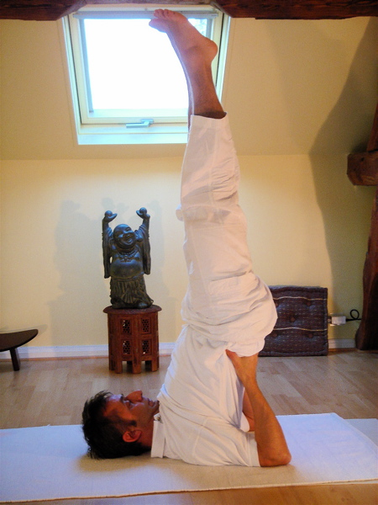Sarvangasana – The Shouder Stand
Sarvangasana is a type of inverted asana from hatha yoga. It is widely considered to be one most important asana.
You first lie on your back with your hands beneath the middle of your back, lifting your lefts into the air so your weight is supported on your head, neck, shoulders, upper back, and arms.
You should be looking toward your toed, and your next should be perfectly straight as you do so. Bending the neck may negate the positive effects of this pose.
Do not attempt this pose without your doctor’s approval if you have any of the following conditions:
- High blood pressure
- Whiplash
- Angina
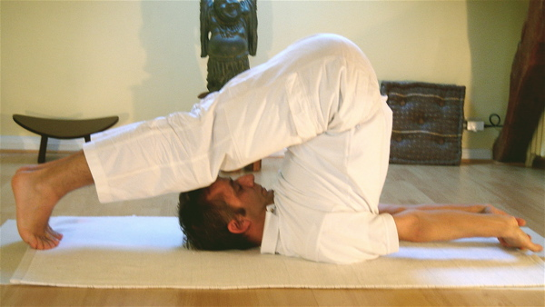
Halasana – The Plow
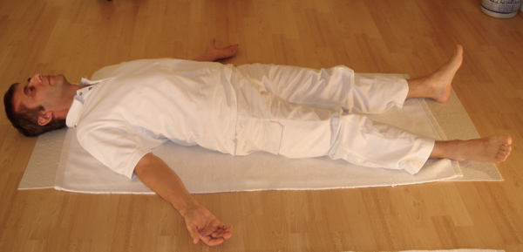
Savasana – The Corpse Pose
Sirsasana – The Head Stand

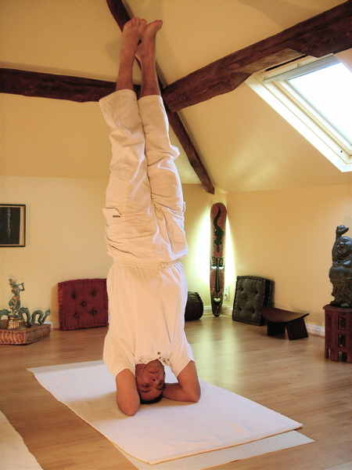

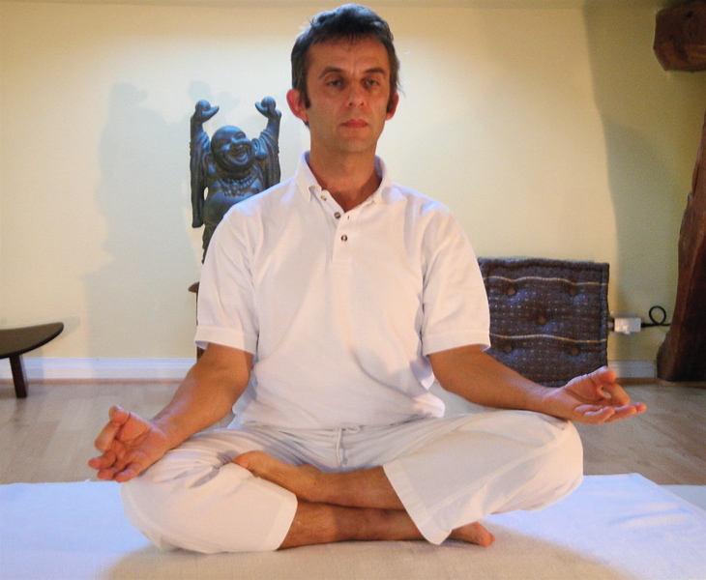
Ardha Padmasana – The Half Lotus

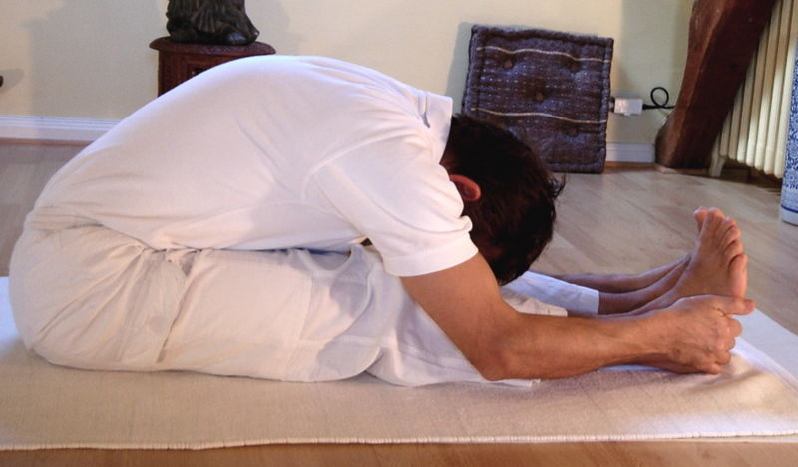
Paschimottanasana – The Intense Stretch of the West

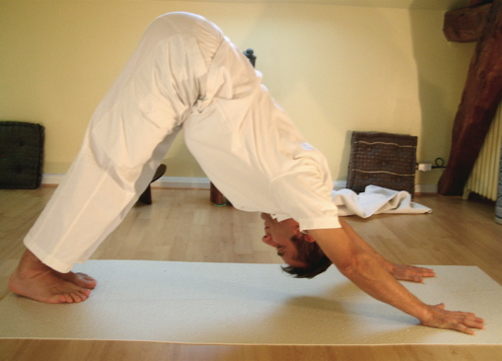
Adho Mukha Svanasana – The Downward Facing Dog

